**HOW TO INSTALL THE JENKINS AND HOW TO USE JENKINS**

**Step1: launch the instance and connect the server and edit security groups (8080) port number.**

**Using some commands:**

* **Sudo su -**
* **apt update –y**
* **ll**
* **sudo apt –get update**
* **sudo apt-get install Jenkins**
* **java –version**

**step2: Jenkins.io open to server and go to documentation and install the Jenkins after go the linux.**

**Long Term Support release**

A [LTS (Long-Term Support) release](https://www.jenkins.io/download/lts/) is chosen every 12 weeks from the stream of regular releases as the stable release for that time period. It can be installed from the [debian-stable apt repository](https://pkg.jenkins.io/debian-stable/).

sudo wget -O /usr/share/keyrings/jenkins-keyring.asc \

https://pkg.jenkins.io/debian-stable/jenkins.io-2023.key

echo "deb [signed-by=/usr/share/keyrings/jenkins-keyring.asc]" \

https://pkg.jenkins.io/debian-stable binary/ | sudo tee \

/etc/apt/sources.list.d/jenkins.list **>** /dev/null

sudo apt-get update

sudo apt-get install jenkins

* **apt install openjdk-11-jre**
* **systemctl start Jenkins**
* **system status Jenkins**

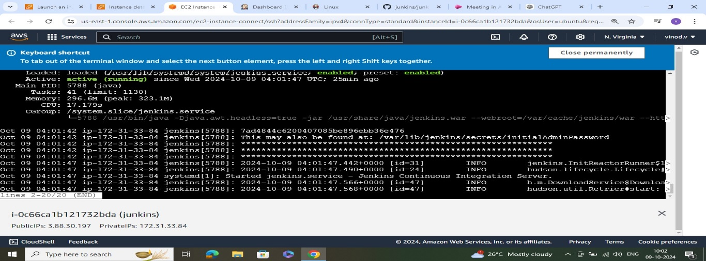

**Step3: After using password login Jenkins and install suggested plugins**

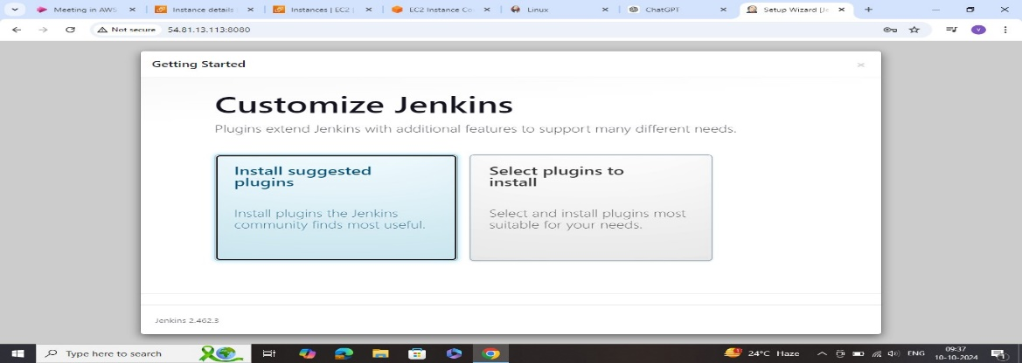

**Step4: Getting started and create first admin user**

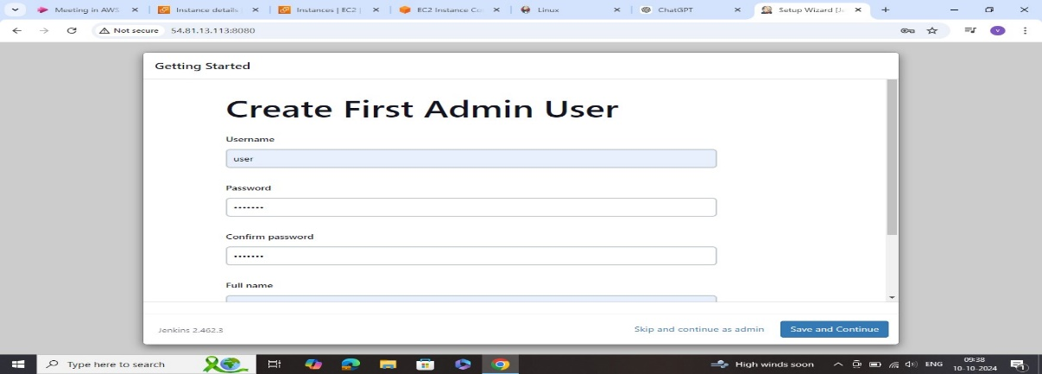

**Step5: instance configuration (save and finsh)**

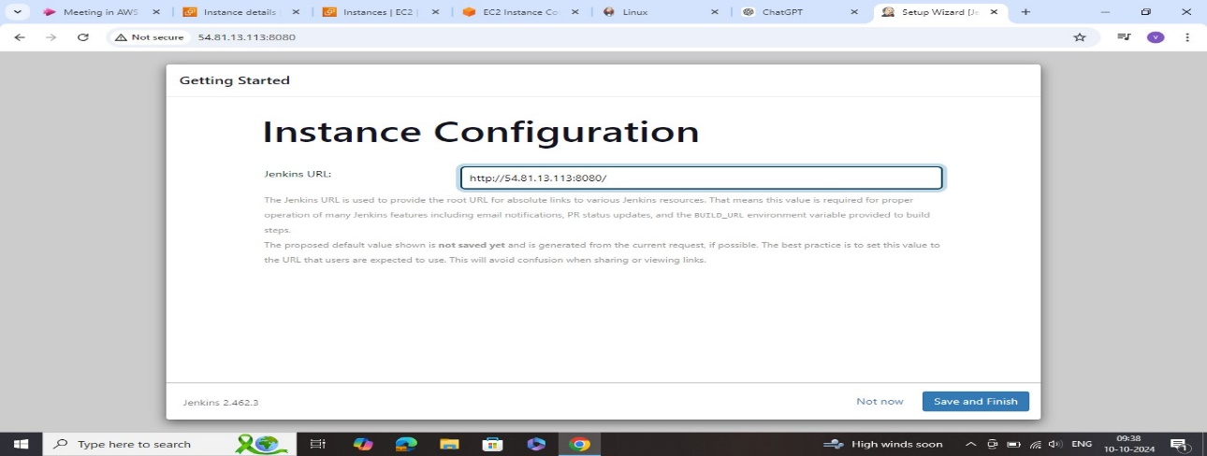

**Jekins is ready!**

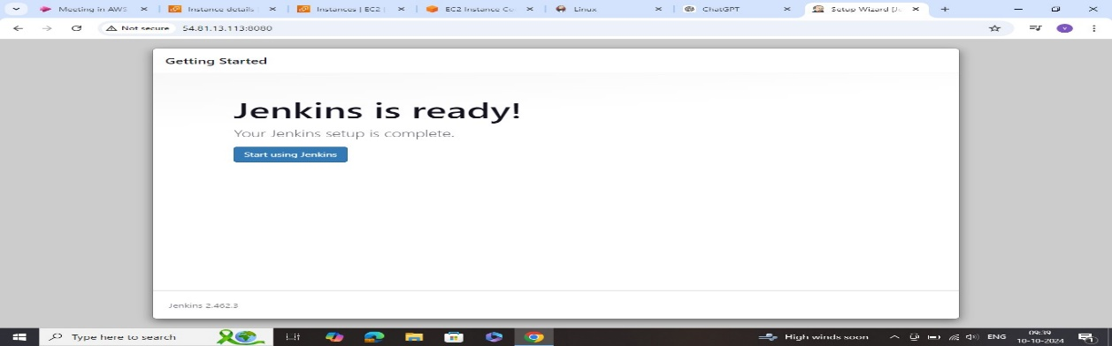

**HOW TO CREATE A JOB**

**Step1: create the new item and do the project freestyle select and ok**

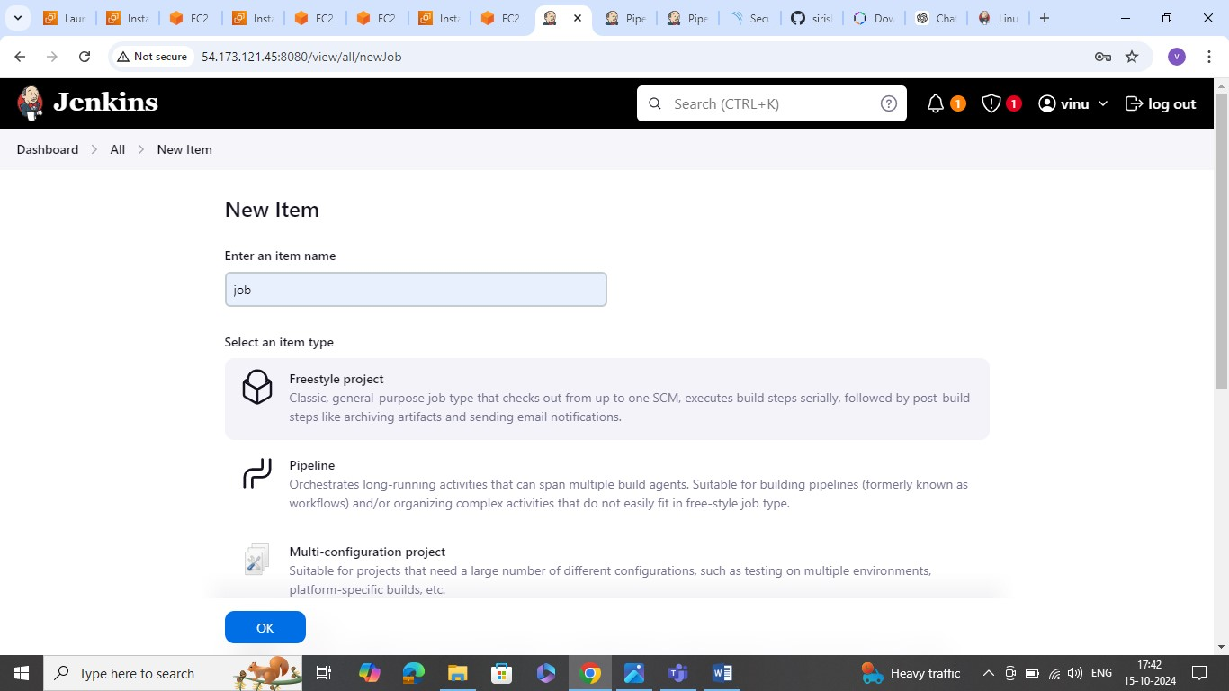

**Step2: Go to configure select the (GIT ) and repository url paste**

* **and branch ( */main )**
* **next click apply and save**
* **To perform exicute the step and build now**
* **Cd /var/lib/Jenkins/ ( it is a default path for Jenkins)**
* **Pwd**
* **Ll**
* **Job**
* **Cd job**
* **Git --version**
* **Cd ..**
* **Cd ( it is move the directory )**
* **Apt install maven**
* **Y**
* **Mvn -v**
* **Mvn clean package (build the code used this command)**
* **ll**
* **cd target/**
* **ll**
* **cd ..//..**
* **ll**

**TOMCAT INSTALLING:**

**Step1: open the server and text the apache.org next click the downloads**

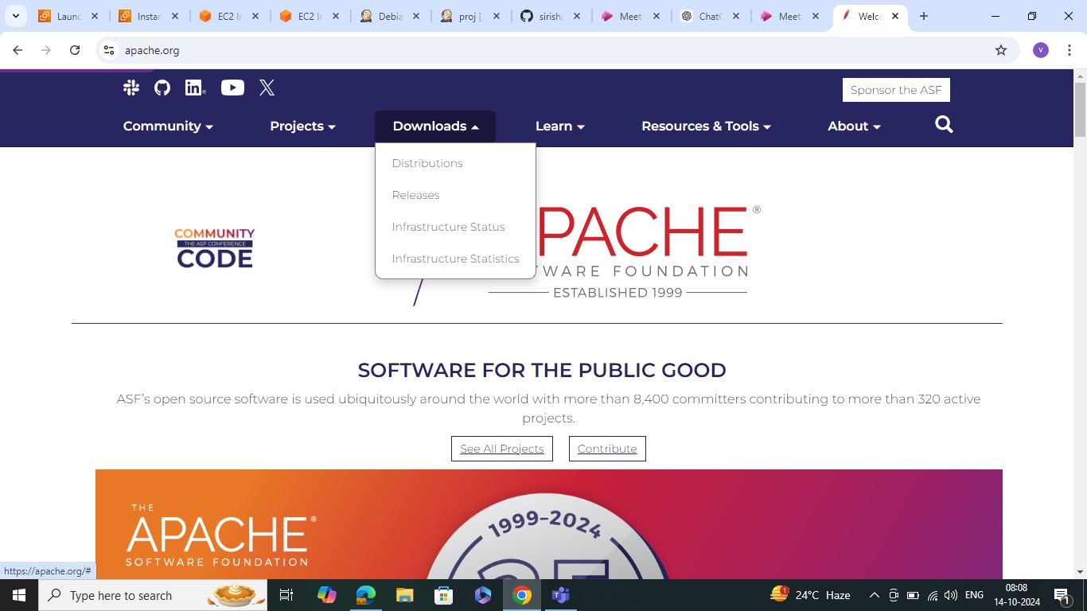

**Tomcat /2024-10-05 17:25 select**

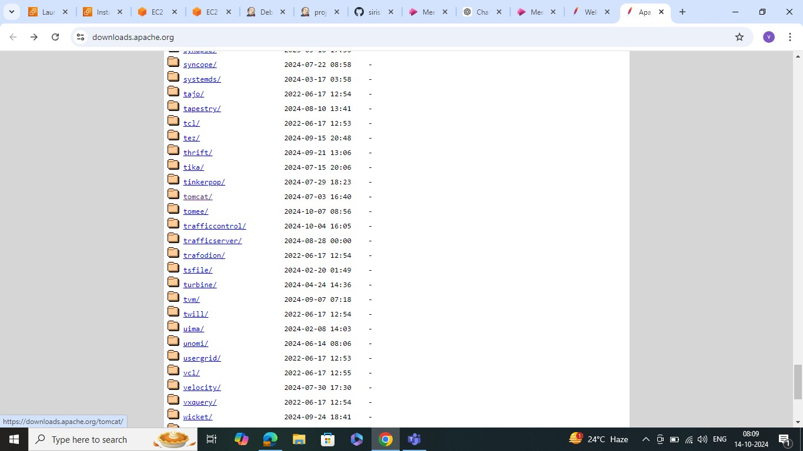

**Index of /tomcat select tomcat-9**

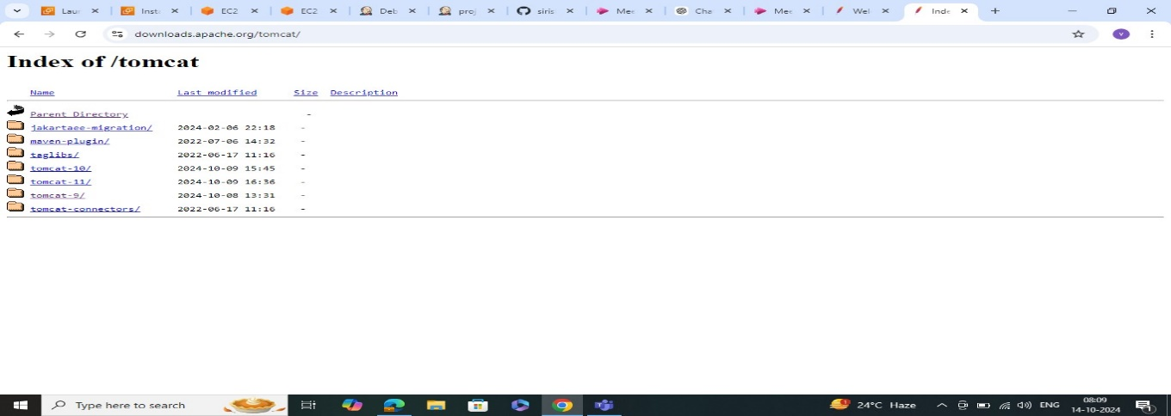

**After go to the bin apache-tomcat-9.0.95.tar.gz ulr copy**

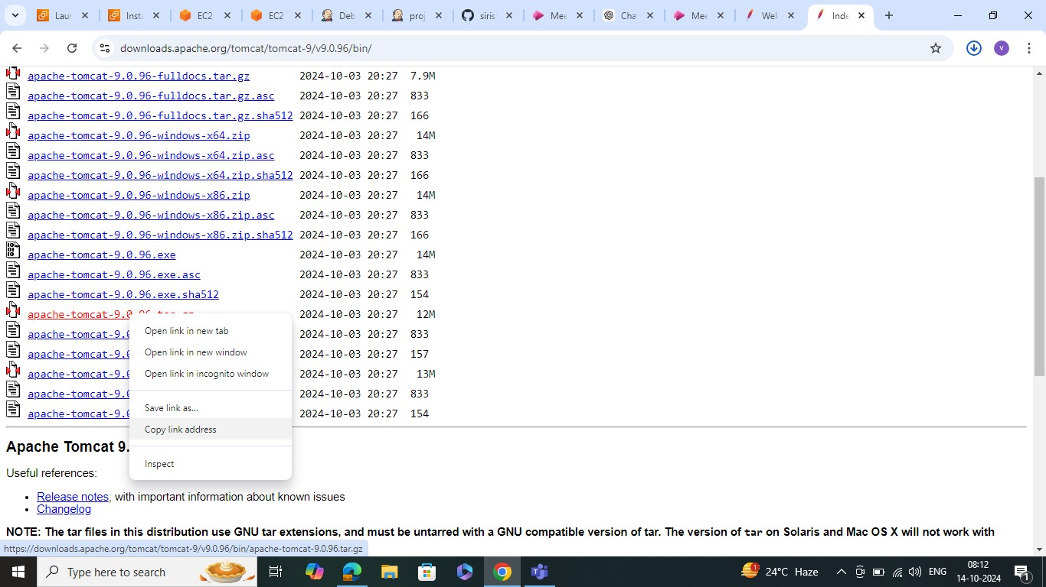

**some commands using open tomcat:**

* **wget (copy url tomcat) used to download the package**
* **ll**
* **tar –zxvf ( copy package)**
* **ll**
* **cd (copy)**
* **ll**
* **cd bin**
* **./ startup.sh\***
* **Sh startup.sh**
* **And edit the inbound rules (8080)**
* **Cd ..**
* **ll**
* **cd webapps/ ( maanger context file open)**
* **ll**
* **cd manager/**
* **ll**
* **cd META-INF/**
* **ll**
* **vi context.xml**
* **edit .* ( replace)**
* **:wq! (save)**

